CREATE TABLE details(

show_id VARCHAR (5),

type_ VARCHAR(10),

title VARCHAR(110),

director VARCHAR (210),

casts VARCHAR (1000),

country VARCHAR(125),

date_added VARCHAR (20),

release_year INT,

rating VARCHAR(10),

duration VARCHAR (10),

listed_in VARCHAR (80),

description VARCHAR (300));

SELECT * FROM details;

-- Netflix Data Analysis using SQL

-- Solutions of 13 business problems

-- 1. Count the number of Movies vs TV Shows

SELECT type_, COUNT(*) as total_content

FROM details

GROUP BY 1;

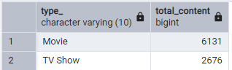

-- 2. Find the most common rating for movies and TV shows

WITH RatingCounts AS (

SELECT

type_,

rating,

COUNT(*) AS rating_count

FROM details

GROUP BY type_, rating

),

RankedRatings AS (

SELECT

type_,

rating,

rating_count,

RANK() OVER (PARTITION BY type_ ORDER BY rating_count DESC) AS rank

FROM RatingCounts

)

SELECT

type_,

rating AS most_frequent_rating

FROM RankedRatings

WHERE rank = 1;

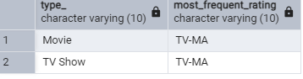

-- 3. List 10 movies released in a specific year (e.g., 2020)

SELECT *

FROM details

WHERE release_year = 2020

LIMIT 10

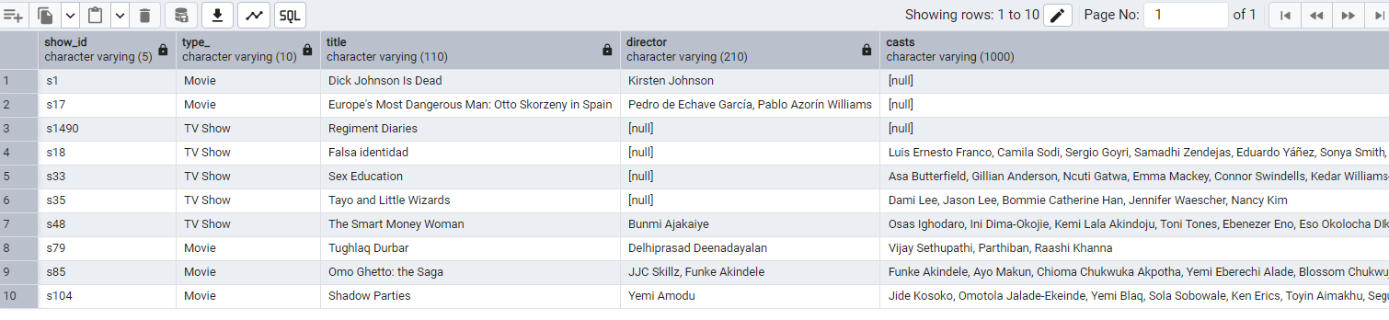

-- 4. Find the top 5 countries with the most content on Netflix

SELECT *

FROM

(

SELECT

-- country,

UNNEST(STRING_TO_ARRAY(country, ',')) as country,

COUNT(*) as total_content

FROM details

GROUP BY 1

)as t1

WHERE country IS NOT NULL

ORDER BY total_content DESC

LIMIT 5

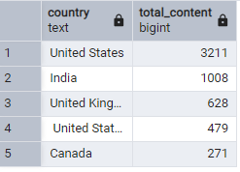

-- 5. Identify the longest movie

SELECT * FROM details

WHERE type_ ='Movie'

AND duration = (SELECT MAX(duration) FROM details);

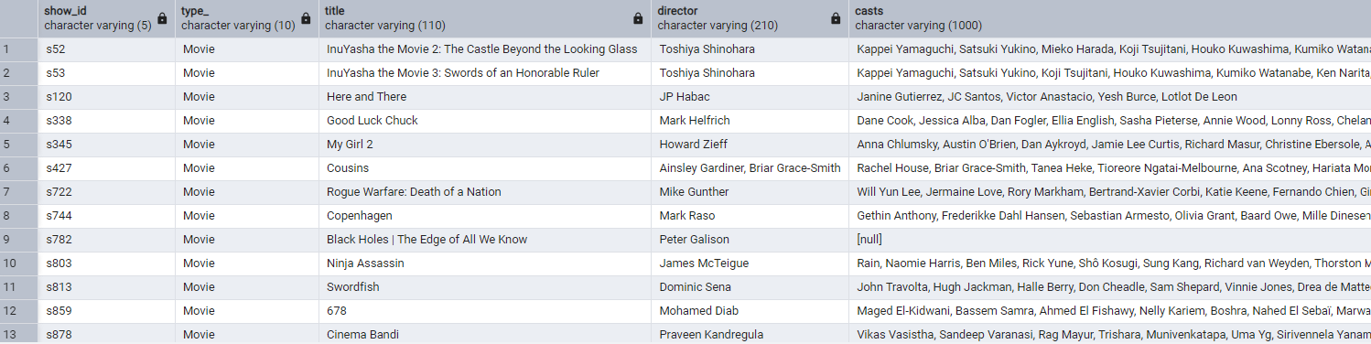

-- 6. Find all the movies/TV shows by director 'Rajiv Chilaka'!

SELECT * FROM details

WHERE director LIKE '%Rajiv Chilaka%';

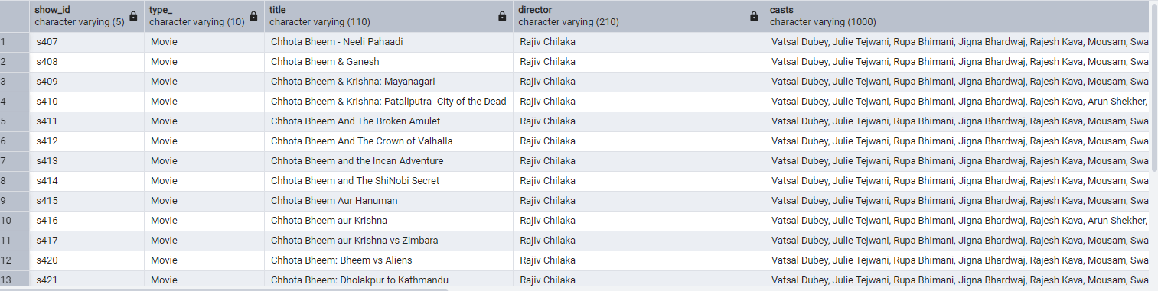

-- 7. List all TV shows with more than 5 seasons

SELECT *

FROM details

WHERE

type_ = 'TV Show'

AND

SPLIT_PART(duration, ' ', 1)::INT > 5

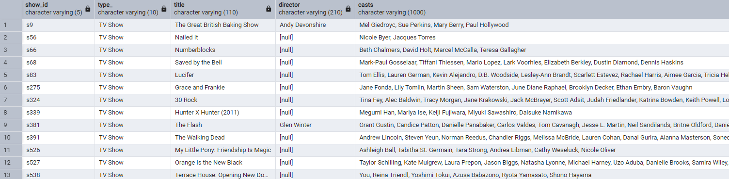

-- 8. Count the number of content items in each genre

SELECT COUNT(show_id) AS items_count, UNNEST(STRING_TO_ARRAY(listed_in, ',')) AS genre FROM details

GROUP BY 2

ORDER BY 1 DESC;

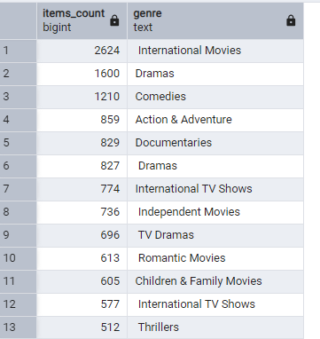

-- 9. List all movies that are documentaries

SELECT * FROM details

WHERE listed_in ILIKE '%Documentaries'

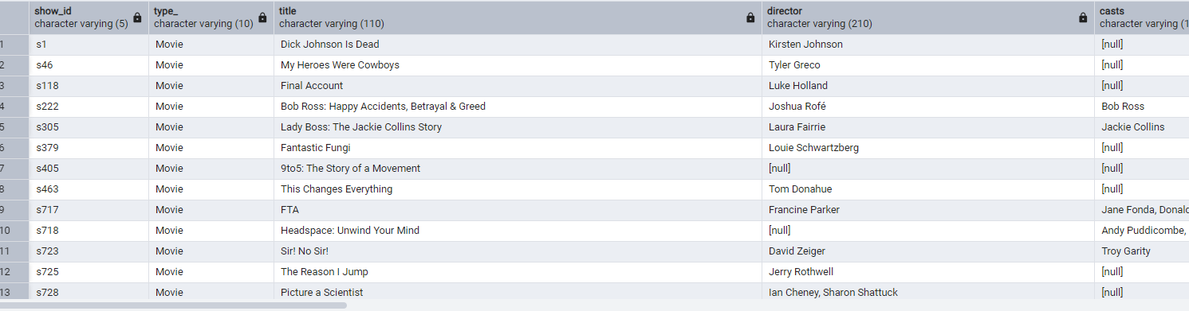

--10. Find all content without a director

SELECT * FROM details

WHERE director IS NULL

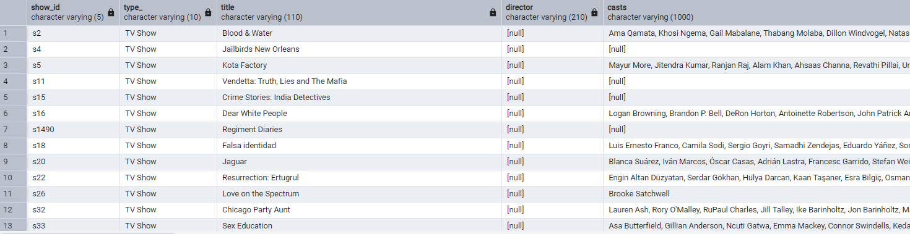

-- 11. Find how many movies actor 'Salman Khan' appeared in last 10 years!

SELECT * FROM details

WHERE casts ILIKE '%Salman Khan%'

AND release_year > EXTRACT(YEAR FROM CURRENT_DATE) – 10



-- 12. Find the top 10 actors who have appeared in the highest number of movies produced in India.

SELECT

UNNEST(STRING_TO_ARRAY(casts, ',')) as actor,

COUNT(*)

FROM details

WHERE country ILIKE '%India'

GROUP BY 1

ORDER BY 2 DESC

LIMIT 10

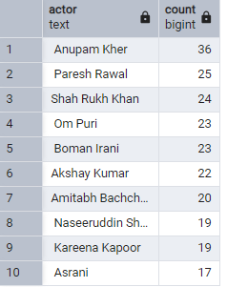

/*

Question 13.

Categorize the content based on the presence of the keywords 'kill' and 'violence' in

the description field. Label content containing these keywords as 'Bad' and all other

content as 'Good'. Count how many items fall into each category.

*/

SELECT

category,

type_,

COUNT(*) AS content_count

FROM (

SELECT

*,

CASE

WHEN description ILIKE '%kill%' OR description ILIKE '%violence%' THEN 'Bad'

ELSE 'Good'

END AS category

FROM details

) AS categorized_content

GROUP BY 1,2

ORDER BY 3 DESC

